DBMS LAB3
Anmol Keswani_ECS_D6-68
Aim: To design and represent an Entity Relationship (ER) diagram for a real-world database system using the draw.io tool by identifying entities, attributes, keys, relationships and cardinalities.
1. Identify all entity types and entity sets.
Researcher- Represents all researchers working in the university.
Department- Represents all departments in the university.
Research Project- Represents all research projects undertaken by the university.
Student- Represents all students working under researchers.
Publication- Represents all publications produced from research projects.
Project Assistant- Represents all assistants associated with research projects.
2. Identify strong and weak entity sets.
Strong and Weak Entity Sets
- Strong Entity Sets:
  - Researcher
  - Department
  - Research Project
  - Student
  - Publication
- Weak Entity Set:
  - Project Assistant
Project Assistant is a weak entity because it is identified only within the context of a particular Research Project.
3. Identify the owner entity and partial key of the weak entity.
Weak Entity: Project Assistant
Owner Entity: Research Project
Partial Key: Assistant_Name
The complete identification of a Project Assistant is: Project_ID + Assistant_Name
4. Simple attributes.
The simple attributes in the University Research Management System are:
- Researcher: Researcher_ID, Name, Date_of_Birth, Email
- Department: Department_ID, Department_Name, Location
- Research Project: Project_ID, Project_Title, Start_Date, End_Date, Budget
- Student: Student_ID, Name, Email, Date_of_Birth
- Publication: Publication_ID, Title, Publication_Date, DOI, Publisher
- Project Assistant: Assistant_Name, Role, Joining_Date
5. Identify composite attributes.
The composite attribute in the system is:
1. Researcher → Address
- Street
- City
- State
- PIN_Code
Address is a composite attribute because it can be divided into smaller component attributes.
Name is treated as a simple attribute because the given problem statement does not specify First_Name, Middle_Name, and Last_Name.
6. Identify single-valued attributes.
Researcher
- Researcher_ID
- Name
- Date_of_Birth
- Email
- Address
Department
- Department_ID
- Department_Name
- Location
Research Project
- Project_ID
- Project_Title
- Start_Date
- End_Date
- Budget
Student
- Student_ID
- Name
- Email
- Date_of_Birth
Publication
- Publication_ID
- Title
- Publication_Date
- DOI
- Publisher
Project Assistant
- Assistant_Name
- Role
- Joining_Date
- 7. Identify multi-valued attributes.
The multi-valued attributes in the system are:
- 1. Researcher → Phone_Number
A researcher can have multiple phone numbers.
- 2. Research Project → Keyword
A research project can have multiple keywords.

8. Identify stored attributes.4
Researcher
- Researcher_ID
- Name
- Date_of_Birth
- Email
- Phone_Number
- Address
  - Street
  - City
  - State
  - PIN_Code
Department
- Department_ID
- Department_Name
- Location
Research Project
- Project_ID
- Project_Title
- Start_Date
- End_Date
- Budget
- Keyword
Student
- Student_ID
- Name
- Email
- Date_of_Birth
Publication
- Publication_ID
- Title
- Publication_Date
- DOI
- Publisher
Project Assistant
- Assistant_Name
- Role
- Joining_Date
9. Identify derived attributes.
Derived Attribute – Age
Age is derived from Date_of_Birth.
Therefore, Age does not need to be stored separately in the database.
In the ER diagram, Age is represented using a dashed oval.
10. Identify key attributes.
Entity | Key Attribute | Key Status
Researcher | Researcher_ID | Primary Key
Department | Department_ID | Primary Key
Research Project | Project_ID | Primary Key
Student | Student_ID | Primary Key
Publication | Publication_ID | Primary Key
Project Assistant | Assistant_Name | Partial Key
Project Assistant | Project_ID + Assistant_Name | Composite Key

11. Identify candidate keys and select appropriate primary keys.
Entity | Candidate Key | Selected Primary Key
Researcher | Researcher_ID | Researcher_ID
Department | Department_ID | Department_ID
Research Project | Project_ID | Project_ID
Student | Student_ID | Student_ID
Publication | Publication_ID | Publication_ID
Project Assistant | Project_ID + Assistant_Name | Project_ID + Assistant_Name
12. Identify at least one composite key.
The composite key is: Project Assistant → Project_ID + Assistant_Name
Assistant_Name alone cannot uniquely identify an assistant because the same assistant name may occur in different projects.
Therefore: Composite Key = (Project_ID, Assistant_Name)
Another composite key occurs in the relational table created for the M:N WORKS_ON relationship: (Researcher_ID, Project_ID)
13. Identify appropriate foreign keys after converting the ER model into relations.
Relation | Foreign Key | References
RESEARCHER | Department_ID | DEPARTMENT(Department_ID)
WORKS_ON | Researcher_ID | RESEARCHER(Researcher_ID)
WORKS_ON | Project_ID | RESEARCH_PROJECT(Project_ID)
STUDENT | Researcher_ID | RESEARCHER(Researcher_ID)
PUBLICATION | Project_ID | RESEARCH_PROJECT(Project_ID)
PROJECT_ASSISTANT | Project_ID | RESEARCH_PROJECT(Project_ID)
RESEARCHER_PHONE | Researcher_ID | RESEARCHER(Researcher_ID)
PROJECT_KEYWORD | Project_ID | RESEARCH_PROJECT(Project_ID)

14. Identify all major relationships between the entities.
Relationship | Entities Involved | Cardinality | Meaning
BELONGS_TO | Department ↔ Researcher | 1 : N | One department has many researchers; each researcher belongs to one department.
WORKS_ON | Researcher ↔ Research Project | M : N | A researcher can work on many projects, and a project can involve many researchers.
SUPERVISES | Researcher ↔ Student | 1 : N | One researcher can supervise many students; each student works under one researcher.
PRODUCES | Research Project ↔ Publication | 1 : N | One project can produce many publications; each publication belongs to one project.
HAS_ASSISTANT | Research Project ↔ Project Assistant | 1 : N | One project can have many assistants; each assistant belongs to one project. This is an identifying relationship because Project Assistant is a weak entity.

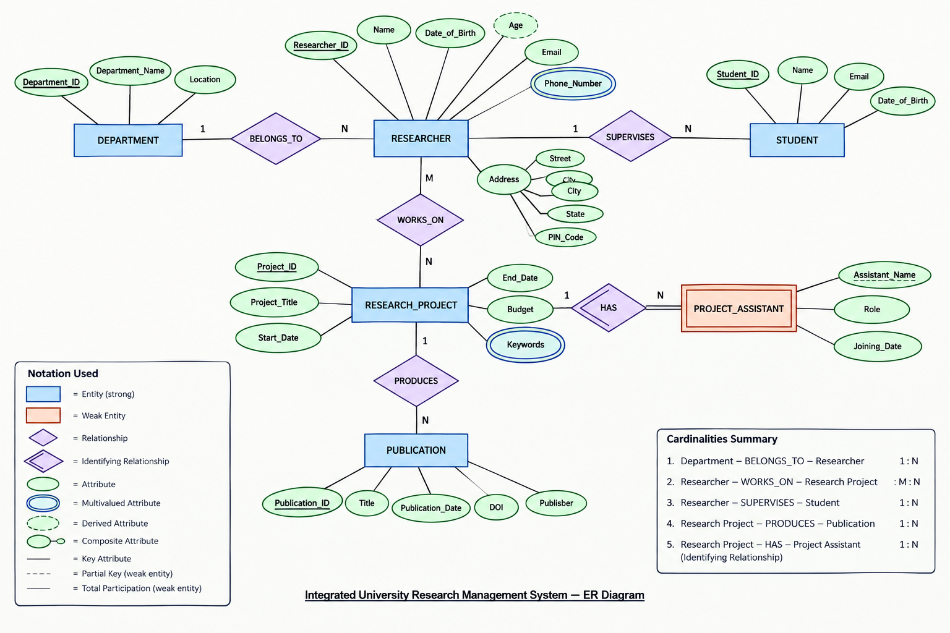
15. Draw the complete ER diagram using standard ER notation.

16. Prepare a table showing each attribute and its attribute type and key status.
Entity | Attribute | Attribute Type | Value | Key Status
Researcher | Researcher_ID | Simple | Single | Primary Key
Researcher | Name | Simple | Single | Non-key
Researcher | Date_of_Birth | Simple | Single | Stored
Researcher | Age | Derived | Single | Derived
Researcher | Email | Simple | Single | Non-key
Researcher | Phone_Number | Simple | Multi-valued | Non-key
Researcher | Address | Composite | Single | Non-key
Researcher | Street | Simple component | Single | Non-key
Researcher | City | Simple component | Single | Non-key
Researcher | State | Simple component | Single | Non-key
Researcher | PIN_Code | Simple component | Single | Non-key
Department | Department_ID | Simple | Single | Primary Key
Department | Department_Name | Simple | Single | Non-key
Department | Location | Simple | Single | Non-key
Research Project | Project_ID | Simple | Single | Primary Key
Research Project | Project_Title | Simple | Single | Non-key
Research Project | Start_Date | Simple | Single | Stored
Research Project | End_Date | Simple | Single | Stored
Research Project | Budget | Simple | Single | Stored
Research Project | Keyword | Simple | Multi-valued | Non-key
Student | Student_ID | Simple | Single | Primary Key
Student | Name | Simple | Single | Non-key
Student | Email | Simple | Single | Non-key
Student | Date_of_Birth | Simple | Single | Stored
Publication | Publication_ID | Simple | Single | Primary Key
Publication | Title | Simple | Single | Non-key
Publication | Publication_Date | Simple | Single | Stored
Publication | DOI | Simple | Single | Non-key
Publication | Publisher | Simple | Single | Non-key
Project Assistant | Assistant_Name | Simple | Single | Partial Key
Project Assistant | Role | Simple | Single | Non-key
Project Assistant | Joining_Date | Simple | Single | Non-key

